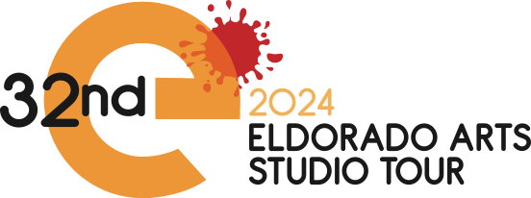
[Participant’s Name] [Participant’s Address]

Dear [Sponsor’s Name],

I am contacting you on behalf of the Eldorado Arts and Crafts Association (EACA) to ask for your support as a sponsor of the 2024 Eldorado Studio Tour.

The Eldorado Studio Tour is the largest artist studio tour in New Mexico. This will be the 32nd year of this special event, where Eldorado Artists will open their private studios to thousands of visitors!

The Tour will be held September 21-22, 10am-5pm, and includes more than 80 artists exhibiting their work in over 60 studios! To preface the event, a Preview Gallery will open on Friday evening - September 20, 5-7pm, and throughout the Tour from 9am-5pm on Saturday and Sunday of the tour.

Please review the attached document outlining the sponsorship levels available to you. Each level comes with a distinct and increasing set of benefits. Most notably, you will benefit from the EACA-generated publicity of ad placements in the Santa Fe New Mexican, radio spots, numerous social media channels, and approximately 8,000 glossy Studio Tour catalogs.

The Studio Tour artists support Eldorado community organizations by donating up to 5% of their sales from the event to local nonprofits, including: the El Dorado Fire and Rescue Service, Vista Grande Public Library, El Dorado Community School Art Program, 285 Recycles and others.

To ensure acknowledgement in our printed materials, your sponsorship form and payment are due by the deadline of June 4, 2024. Return to the artist you are sponsoring or mail to the address below. If you have any questions, please contact Chuck Boxwell, Sponsorship Committee Chair, at cboxwell@mindspring.com or (213) 304-8022

I also want to invite you and your staff to the Artist Reception and Preview Gallery on Friday evening, September 20, 5 – 7 pm, in the Eldorado Community Center (1 Hacienda Loop, Santa Fe, 87508).

Sincerely,

[Artist’s Signature] [Artist’s printed]

